# Research

We’ve had a look on several volunteer websites in Australia and chosen some as samples for our website

## First Page: Australian Volunteers

* + 1. URL: <https://www.australianvolunteers.com/>
    2. We have decided that the **home page** of our website will look similar to this website. Its design is simple yet effective, so our product’s design will mainly follow it.
    3. We will design our **header** similar to it (as shown below), as the logo is eye-catching, every section including login section are clearly shown and easy for users to know and understand every available features on header

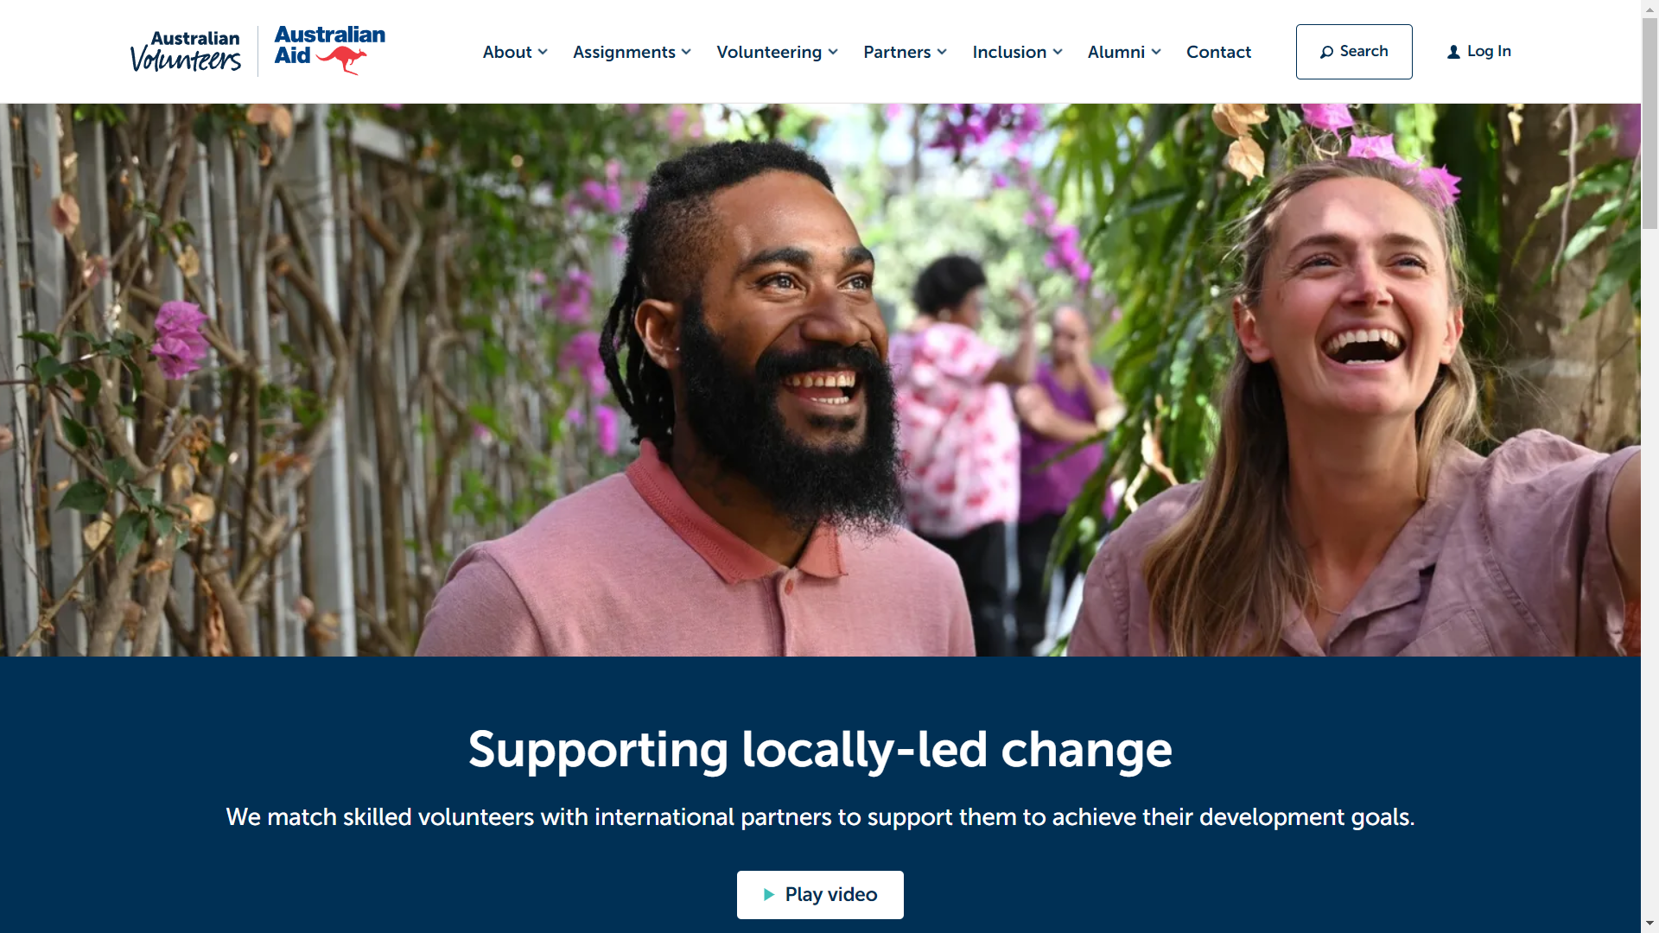

* + 1. We will also follow their **login page** design, as it is simple and focused. Login stage is pivotal as it provides information to distinguish between members, managers and sysadmin, we believe this design will help users to focus more while on the login stage and avoid mistyping errors

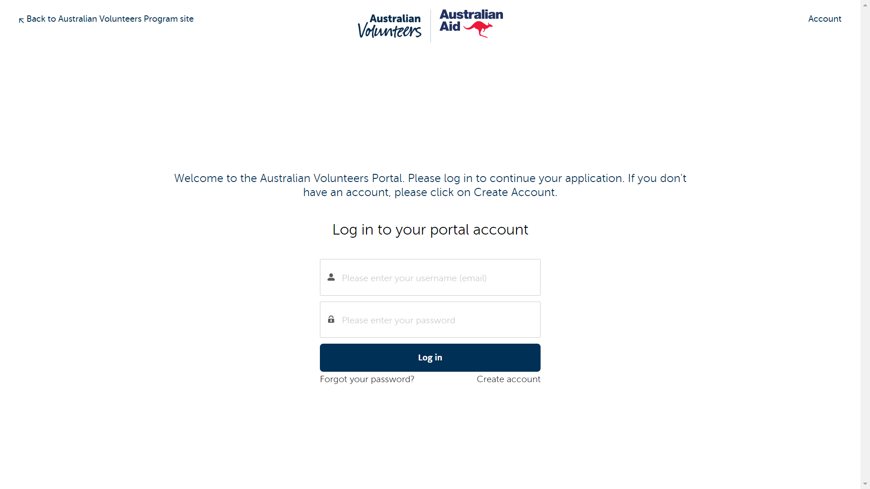

* + 1. Each of our events or news pages will follow their design. With main content on the left and important information will be arranged on the right. This design is simple for users to understand yet shows every crucial information.

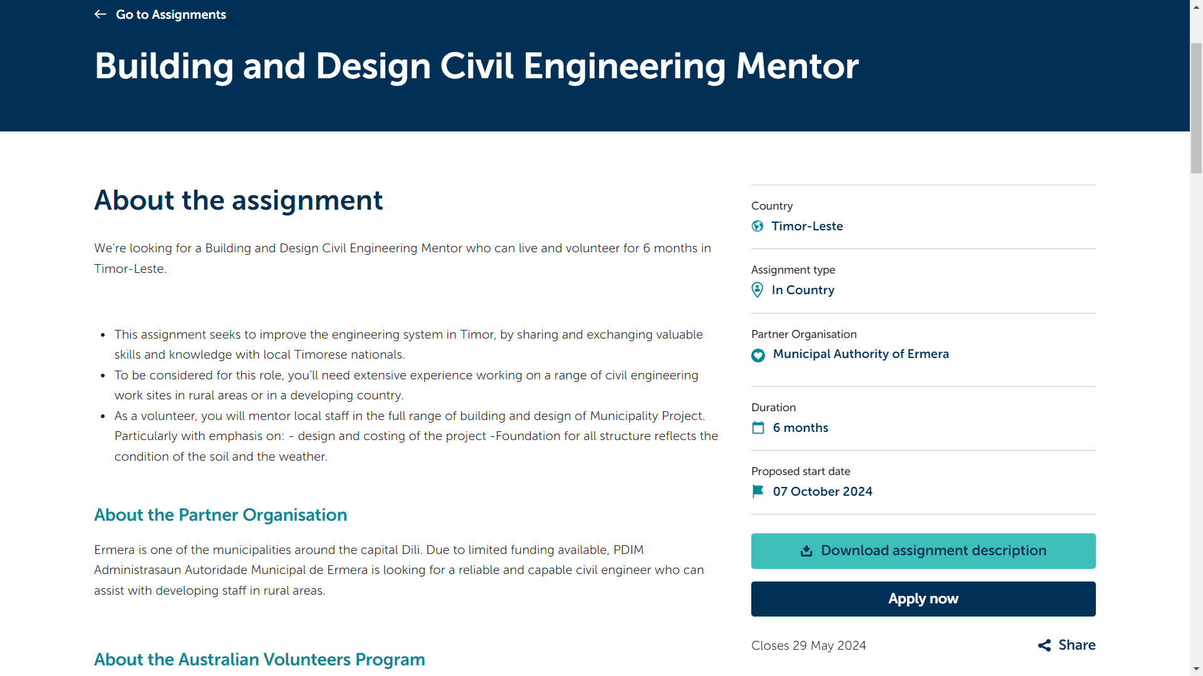

* + 1. Their design of the mailing subscription section will also be followed. 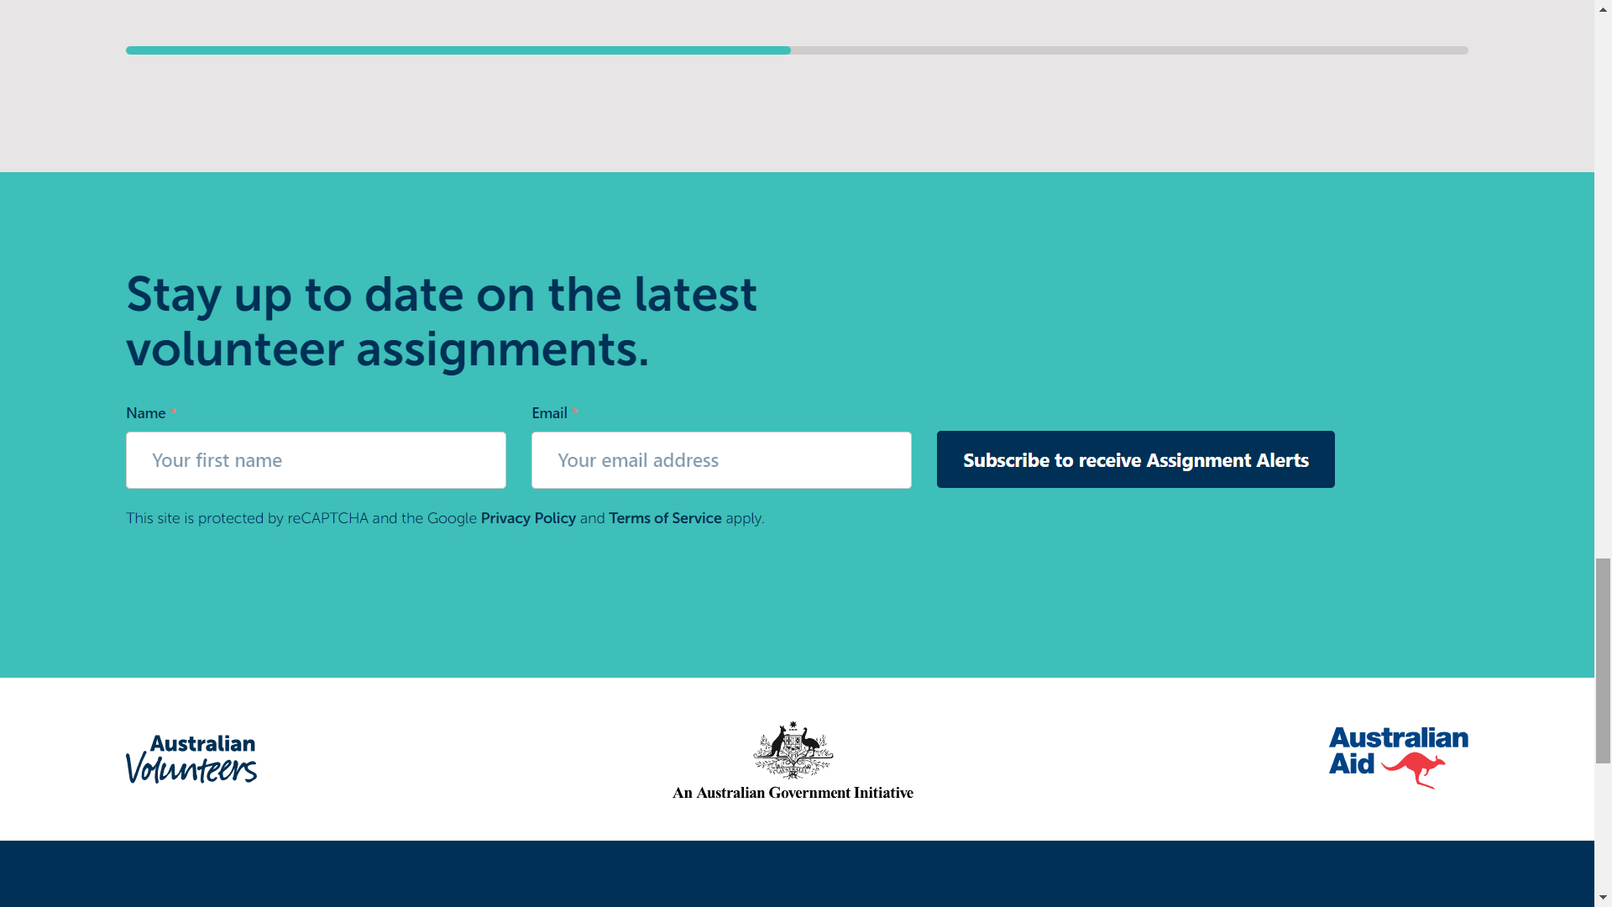

## Second Page: Flying Doctor

* + 1. URL: <https://www.flyingdoctor.org.au/>
    2. We will follow the state selection feature and its design of this website for our branch selection. We believe it is intuitive and easy for users to understand what it is for. Also, allowing users to choose a branch will help them to know news and events that are most related to them.

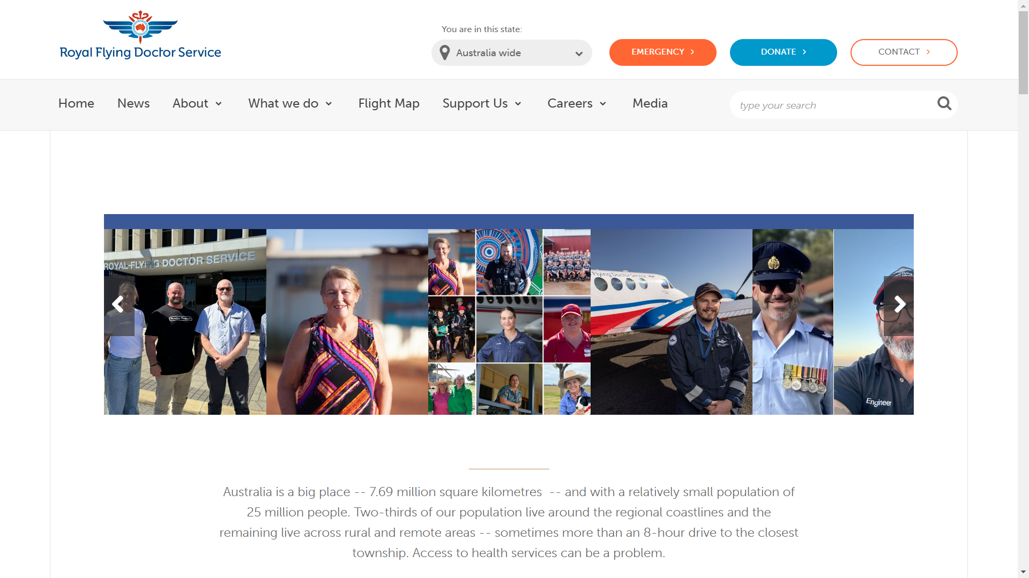

* + 1. We will also follow their main page’s structure and show our organization's latest news on our main page. We believe this design will help users to better understand what our organization is doing.

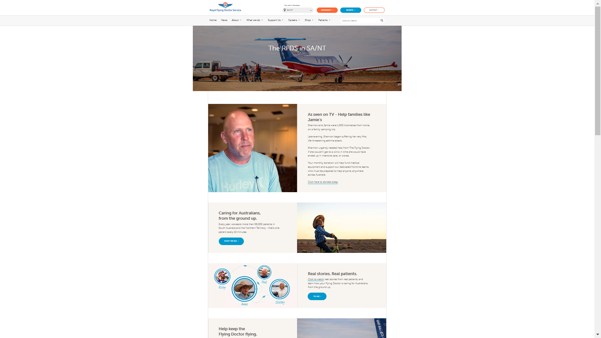

## Third Page: Fight Cancer Foundation

* + 1. URL: <https://www.fightcancer.org.au/>
    2. We will follow their structure for events and news sections. News or events will be arranged horizontally with their basic information. This design is eye-catching and intuitive, users will quickly get what is there in the event or news and hence it is easier for them to choose which one to read.

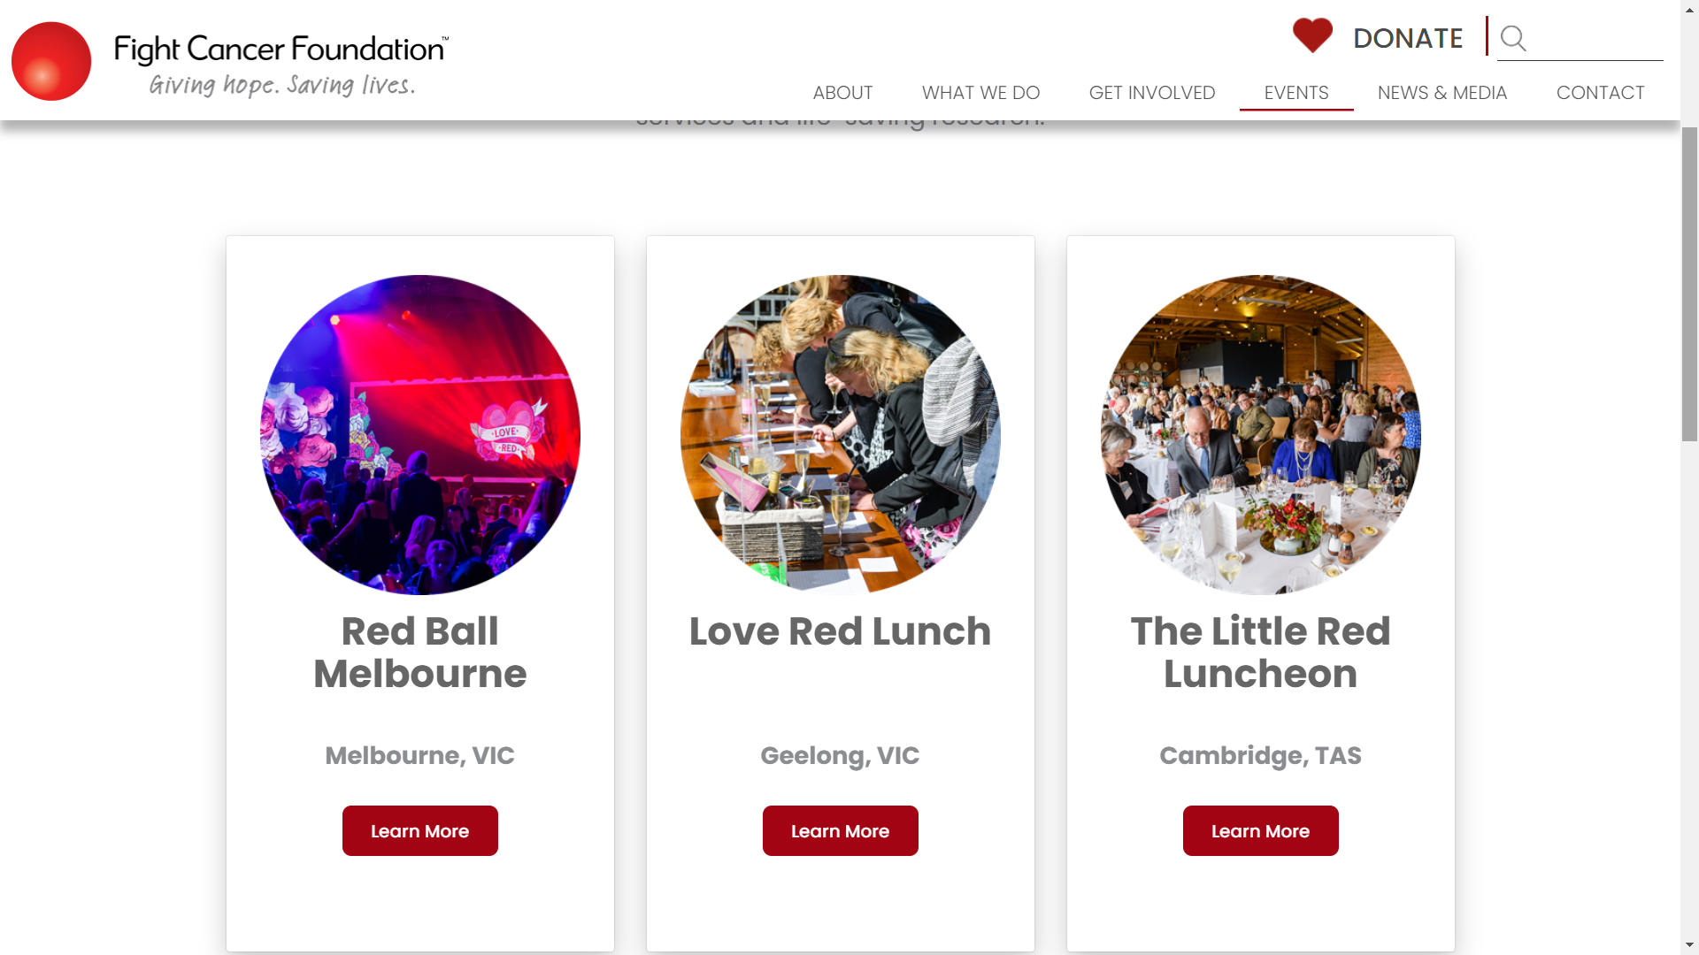

# Design

We have attached our design in draw.io below. Please choose open with draw.io to fully see our design.

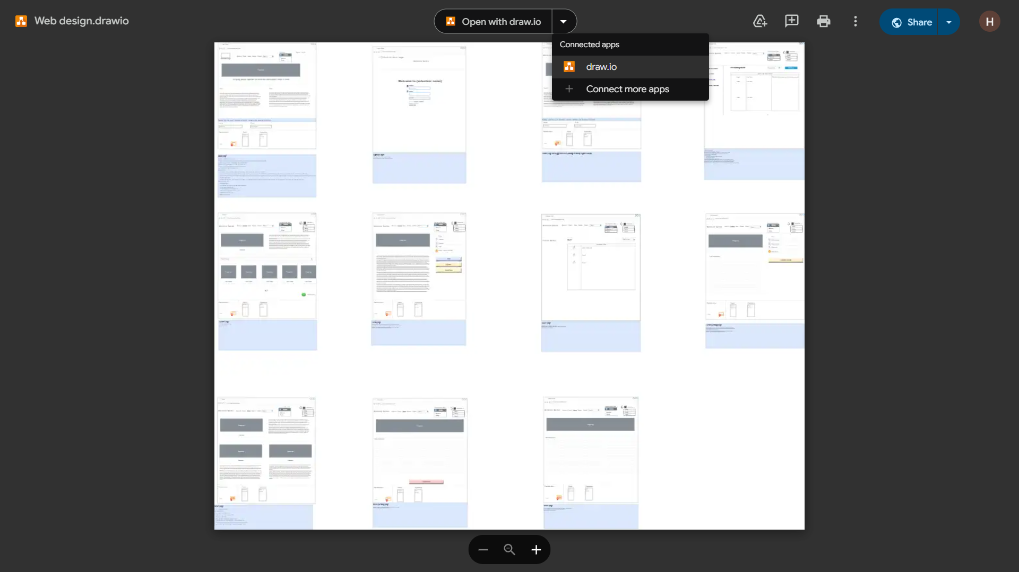

<https://drive.google.com/file/d/1VTwXB23JpR8c3bSNkjS3quAY9b_NHoht/view?usp=drive_link>

# Features

## Signup/ Login

* + 1. **Design**: The signup/login design will follow The Smith Family and Australian Volunteers pages. An additional signup option next to the login option will be included to make it more intuitive and reduce cognitive load for users.
    2. **Process**: Users can sign up or log in using the provided forms. Successful authentication will redirect users to their dashboard.

## Manage user information:

* + 1. **Post-login Changes:**
       1. After logging in, the signup/login option changes to the user's name.
       2. Hovering over this section reveals a dropdown list with options for profile, settings, logout, etc.
    2. **Profile Management:**
       1. **Users** can manage their personal information such as username, phone number, email, etc.
       2. **Managers** can view member information.
       3. **Sysadmins** can set managers, add branches, and manage users through additional options in this dropdown.

## Search bar:

* + 1. **Location***:* On the event page, there will be a search bar to search for specific events, similar to the Australian Volunteer page.
    2. **Functionality***:* Users can enter a query to find relevant events, with results displayed dynamically.

## News on main page:

* + 1. **Display**:
       1. Following from flyingdoctor, we will put the most recent updates on the main page, right below the search bar.
       2. Each update entry will include a headline or title, along with a brief summary or excerpt to provide context and encourage further engagement.
    2. **Dynamic Content**:
       1. The content displayed in the recent updates section will be dynamically generated based on the latest additions or modifications to the website's news feed or update database.
       2. This ensures that users always have access to the freshest information without the need for manual updates or intervention.

## Mailing:

* + 1. Location: At the bottom of the main page, there will be a mail subscription form. This encourages users to scroll through the entire page before subscribing, making it convenient to join the mailing list after learning about the organization.
    2. Users will have the option to unsubscribe or manage their subscription preferences at any time, ensuring transparency and compliance with privacy regulations.

## Choose branches:

* + 1. **Design and Placement:**
       1. Inspired by the *Royal Flying Doctor website*, users can select the branch they want to view from a list at the navigation bar. This list will be in the form of a dropdown menu of clickable branch names.
       2. This feature enhances user experience by providing quick access to localized content. It allows users to easily navigate and find information pertinent to the geographical area they are interested in.
    2. **Dynamic Content Update:**
       1. Upon selecting a branch, the main page content, including news updates, events, and other relevant information, will dynamically update to reflect the selected branch's specific content.
       2. This ensures that users receive location-specific information relevant to their interests.

## Style:

* + 1. We will follow the *Australian Volunteers*’ style. The Australian Volunteers’ website style is known for its simplicity, effectiveness, and user-friendliness.
    2. By adopting a similar design, we aim to provide an intuitive and engaging user experience.

## Post update:

* + 1. Structure:
       1. Similar to Facebook groups, when managers click the “new post” button, a textbox will appear allowing them to enter the title and content.
       2. They can choose to post it privately or publicly.
    2. User View:
       1. Non-member or member users will see updates on the news page, similar to news.com.au.
       2. Only the first 5 lines of content will be shown, with an option to click on the title to view the full update on a separate page.

## Post event:

* + 1. **Manager Functionality**:
       1. On the event page, managers will have a "post event" button above the search bar.
       2. Clicking it allows them to enter the title and content for a new event.
       3. Managers can update the status of the event via an "update" button on each event page.
    2. **Event Page Design**:
       1. The event page design will follow Australian Volunteers, with a fixed join button.

## Show RSVP:

* + 1. On the right-hand side of the specific event page, there will be a button called ”Show RSVP” to provide event managers with quick access to view the RSVP list for the corresponding event.
    2. Only managers and authorized personnel will have access to this button, ensuring that sensitive event attendee information is only visible to authorized individuals.
    3. When a manager clicks on the "Show RSVP" button, a modal or popup window will appear, displaying a list of attendees who have RSVP'd for the event.

## Join event:

* + 1. **Visibility:**
       1. For each event displayed on the event page, a "Join" button will be provided.
    2. **User interactions:**
       1. When a non-member user clicks the "Join" button, they will be directed to a login page if they are not already logged in or sign up page if they don’t have an account.
       2. After logging in, the user will be redirected back to the event page, where they can proceed with joining the event.
    3. **Event Status Check:**
       1. Before displaying the "Join" button, the system will check the status of the event.
       2. If the event status is marked as 'done', indicating that it has already taken place, the "Join" button will not be displayed to prevent users from attempting to join a concluded event.
    4. **User Feedback:**
       1. If a non-member user clicks the "Join" button but is redirected to the login page, they will receive a notification or message informing them of the login requirement before they can join the event.

## User management by sysadmin:

* + 1. Sysadmins can navigate to a page where all users are listed with columns for username, role, and actions.
       1. Username: Displays the username or display name of each user.
       2. Role: Indicates the role or level of access assigned to each user (e.g., regular user, manager, sysadmin).
       3. Actions: Provides options for performing actions related to user management, such as editing user details, changing roles, or deleting users.
    2. Search Functionality:
       1. Located in the top right corner of the user management page, a search bar will allow sysadmins to quickly search for specific users by username or other criteria.
       2. The search functionality enhances usability by facilitating efficient user lookup and management, particularly in cases with a large user base.
    3. Add User Button:
       1. Also located in the top right corner, an "Add User" button provides sysadmins with the ability to create new user accounts directly from the user management page.
       2. Clicking the button will open a form where sysadmins can input the necessary user details, such as username, email, password, and role assignment. When adding a new user, sysadmins can assign a role or level of access to the user based on their responsibilities and permissions within the system.

## Branch management by sysadmin:

* + 1. Similar to the "Add User" button in user management, an "Add Branch" button will be provided on the branch management page. Clicking this button enables sysadmins to create new branch entries within the system. Sysadmins can input branch details such as name, location, and manager assignments via a form that appears upon clicking the button.
       1. Branch Name: Displays the name or identifier of each branch.
       2. Location: Indicates the geographical location or address of the branch.
       3. Managers: Lists the managers or administrators assigned to oversee operations at each branch.
    2. Clicking on a branch allows the sysadmin to see all events and managers associated with that branch.

# Review

We believe that our design minimizes kinematic and cognitive load and meet the standards & heuristics referenced in the lecture

* 1. Navigation bar
     1. As navigation bar is the most important element to help users to discover our pages, we presented links to every essential page on our navigation bar. Also we have made all the buttons to be relatively large and at a reasonable distance to each other so that users can easily interact with them.
     2. When users hover on the sections, the icon will change color so that user well aware which page they will be directed to
     3. When users are in a page, the color of the icon of that page will change to gray so that users always know where they are.
  2. Login/Signup buttons
     1. Unlike many websites, we decided to put signup and login buttons next to each other instead of putting signup links within the login page. We believe this will help new users to easily understand where to create an account instead of guessing its whereabouts.
  3. Sticky information
     1. In the eventPage, the additional information is made to be sticky so that users are always aware of important information about that event without having to navigate back to the top.
  4. Events and news order
     1. We always order news and events in reverse chronological order. Because more recent news and events are more likely to be searched for, we believe arranging news and events in this order will help users to quickly and easily find what they need.
  5. Hide invalid operation
     1. Since only managers and sysadmin are allowed to perform some actions, we always hide invalid actions from users, such as managing branches or managing users’ information. We believe hiding them is the most efficient way to prevent users from making severe errors.
  6. Consistent Layout:
     1. Each page on our website maintains a uniform layout and design, featuring a primary section housing essential information and secondary subsections for additional details. Each section is accompanied by relevant images and descriptive text. The primary section is usually placed at the beginning, has large images as well as texts and looks visually appealing.
  7. Visual Hierarchy:
     1. To guide users' attention to the most important elements on each page, we use bold texts or appealing fonts. This will make it easier for users to prioritize information and actions.
     2. On our home page, we divide the website into different sections so that user can have a general overview of what our organization is like.

1. Data plan
   1. **Signup/ Login**
      1. **Process**:
         1. When a user signs up or logs in, their information is sent to the server via a POST request.
         2. The server verifies this information against the database.
         3. The server responds with a status code indicating success or failure.
         4. The client allows the user to proceed or prompts for re-entry based on the response.
      2. **Authorization**: Upon successful login, an isAuthorised cookie is stored, allowing users to stay logged in for future sessions.
      3. **User Role**: The user's role is also saved in a cookie for quicker page content processing.
   2. **Events and News**
      1. **Main Page Access:** 
         1. When users first access the main page, the server queries all related news based on the user's current branch and stores this information as a JavaScript Object in the session.
         2. The server processes and displays the main page content accordingly.
         3. Similarly, content on News and Event page will also be processed by the server and display accordingly
      2. **Event/News Access:** 
         1. When users choose a particular news or event to view, a GET request with news or event id as parameter will be sent to the server
         2. the server will process the content of the news or event accordingly and send an HTML back to the client to display.
   3. **Manage user information:**
      1. **User Dropdown**:
         1. After logging in, the signup/login option changes to the user's name.
         2. Hovering over this section reveals a dropdown list with profile, settings, logout, etc.
      2. **Profile Management:**
         1. *Users* can manage personal information such as username, phone number, and email.
         2. *Managers* can view member information.
         3. *Sysadmins* can manage users, set managers, and add branches.
   4. **Search bar:**
      1. **Process**:
         1. When a user enters a query into the search bar and submits it, the client sends a request to the server.
         2. The server, which hosts the search functionality and database of indexed content, processes the query, searches through the indexed data, and identifies relevant results.
         3. These results are then sent back to the client, which displays them to the user.
         4. The client-side interface presents the search results
   5. **Mailing:**
      1. When non-account users opt to receive mail, their information is sent to the server via a POST request.
      2. The server saves their email in the database.
   6. **Branches:**
      1. The selected branch will be stored in a cookie to remember the user's choice for future visits, ensuring a seamless experience.
      2. The server will query the database for content related to the selected branch and update the page content accordingly without requiring a full page reload.
   7. **Post**
      1. When news or events are posted, a POST request sends the data to the server.
      2. The server saves it to the database and updates the corresponding session JavaScript Object.
   8. **RSVP**
      1. When members RSVP to an event, their user ID and the event ID are sent to the server via a POST request and stored in the database.
      2. Managers can view RSVPs by sending a GET request to the server, which queries the database and returns a JSON object with the results.
   9. **User management**
      1. When sysadmin choose to view user information, a GET request will be sent to the server and the server will query database and then send a JSON object back to client
      2. After the sysadmin make changes, a list of updates in the form of a JSON object will be sent to the server using a POST request and the server will make changes to the database accordingly.
   10. **Sysadmin add branch**
       1. Sysadmins navigate to the branch management section and input details for a new branch.
       2. This information is sent as a POST request to the server.
       3. The server updates the database and sends a 200 OK response upon successful addition of the branch.

# Database Schema

